**Practical 10**

**(PART – A)**

|  |  |
| --- | --- |
| Roll No. A016 | Name: Varun Khadayate |
| Program: B-Tech (CSBS) | Division: SY |
| Batch: 1 | Date of Experiment: 25-09-2020 |
| Date of Submission: 25-09-2020 | Grade: |

***Aim: Transform Grammar***

**Outcome:** After successfully competing of this practical, students will be able to learn:

* How to use JFLAP to
  + transform context free grammar into CNF (Chomsky Normal Form)
  + Remove Lamda productions
  + Remove Unit productions
  + Remove useless productions
  + Convert to CNF

**A.1 Reading**

Read Page 127 to 138

**A.2 Tasks**

Using JFLAP tool for all problems given below:

1. Simplify the following grammar by removing the useless symbols

G = {(S,A), (1,0), P, S}

Where, P consists of the following productions

S->10 | 0S1 | 1S0 | A | SS

1. Eliminate unit productions from the following grammar:

S ->a | Xb | aYa | b | aa

X->Y

Y->b | X

1. Eliminate €-productions from the grammar G, which is defined as:

A -> aBb | bBa

B->aB | bB | €

1. Convert the following CFG to CNF

S -> aSa | bSb | a | b | aa | bb

**PART B**

(PART B: TO BE COMPLETED BY STUDENTS)

**(Students must submit the soft copy as per following segments within two hours of the practical. The soft copy must be uploaded on the Portal or emailed to the concerned lab in charge faculties at the end of the practical in case the there is no portal access available)**

**B.1 Output:**

1. Mention the steps that you have taken for problem 1, 2, 3, 4 mentioned in Part A

* Load the grammar
* Click on the Convert menu
* click on Transform Grammar

The above are the main key steps

**PART-I: Remove Lambda Productions**

* After clicking Transform Grammar, JFLAP will open the tab Lambda Removal
* Click on Do All
* Since lambda removal is complete, we can click Proceed and move on to the next step.

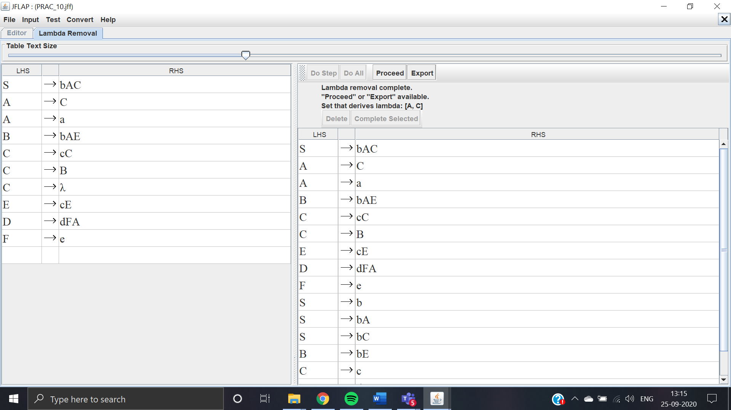

**PART-II: Remove Unit Productions**

* After the proceed step, click on Do All to see the Removal of Unit Productions
* Since unit production removal is complete, we can click Proceed and move on to the next step.

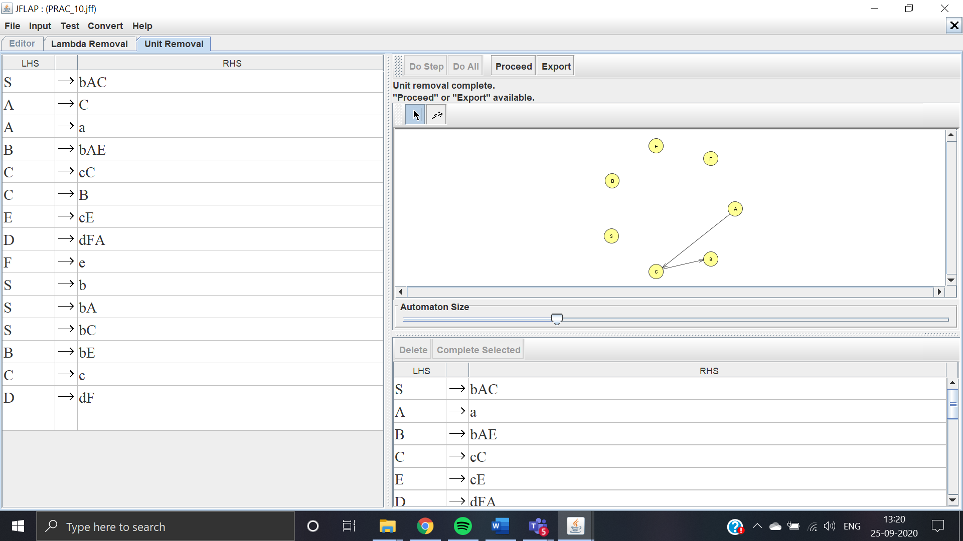

**PART-III: Remove Useless Productions**

* After the proceed step, click on Do All to see the Removal of Useless Productions
* Since useless production removal is complete, we can click Proceed and move on to the next step.

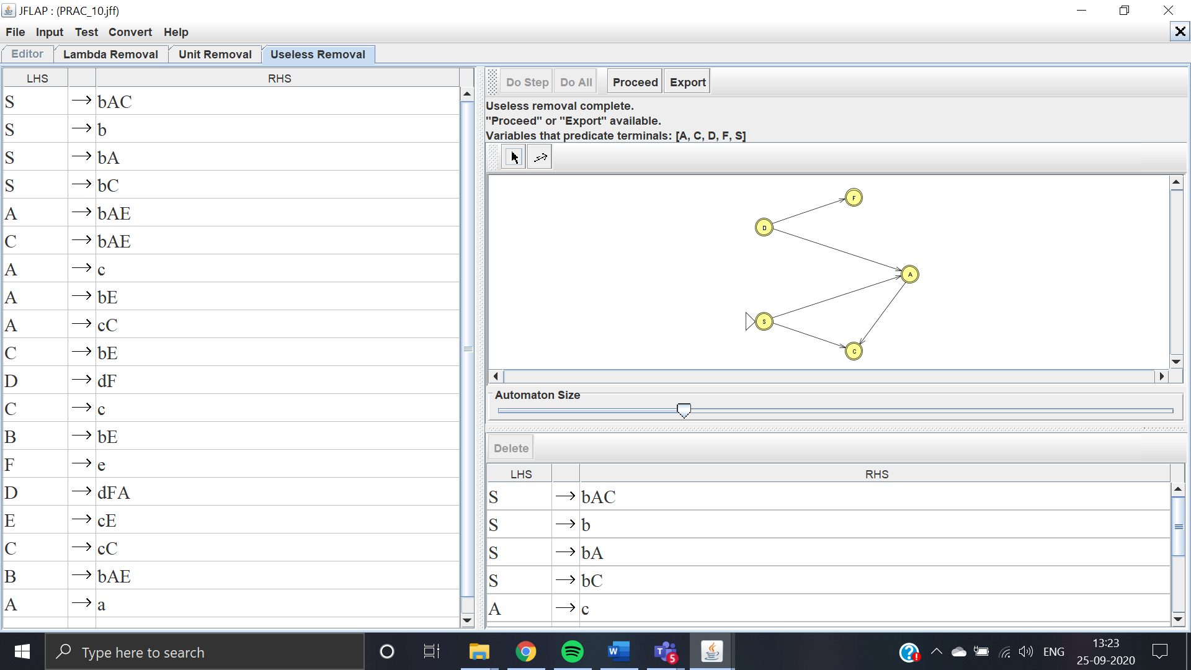

**PART-IV: Convert to CNF**

* Now, we are at the final step of converting our grammar to CNF
* click on Do All to finish the conversion.
* After we are finished with the conversion, the grammar will be in CNF

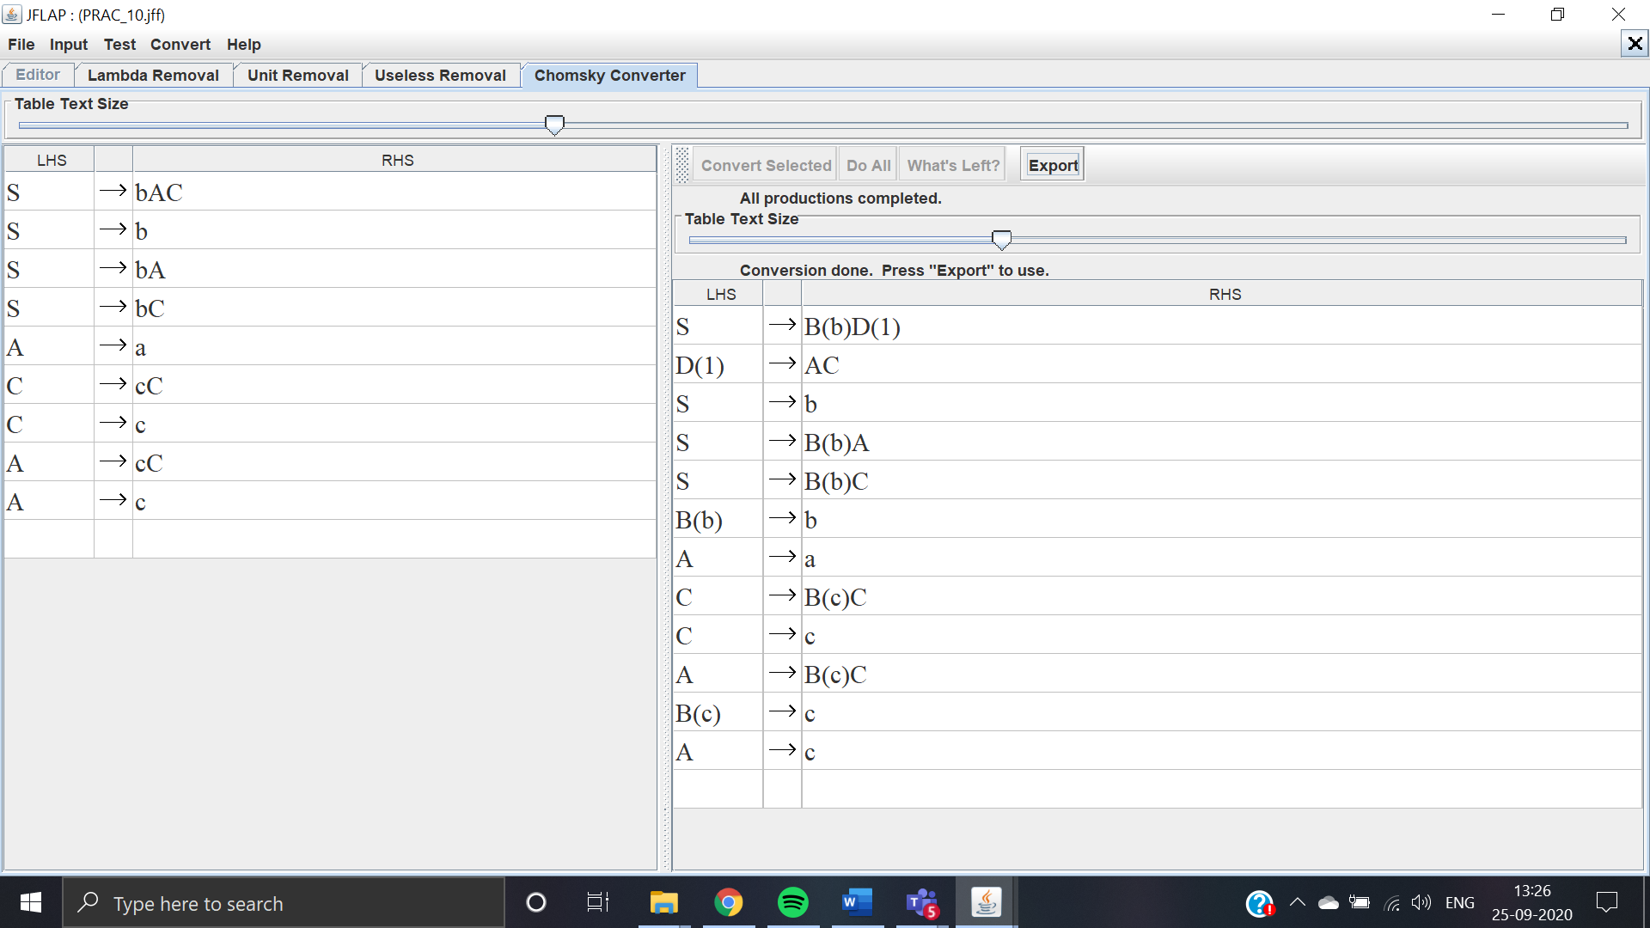

**B.2 Observations/Learning**

*(Students are supposed to write the logic of constructed DFA and generated regular expression)*

We are able to convert the grammar into 4 different types namely:

* Remove Lambda Productions
* Remove Unit Productions
* Remove Useless Productions
* Convert to CNF

**B.3 Conclusion:**

*(Students must write the conclusion as per the attainment of individual outcomes and learning/observation)*

The conclusion was derived from the experiment was that the grammar is able to convert itself into 4 types of production namely:

* Remove Lambda Productions
* Remove Unit Productions
* Remove Useless Productions
* Convert to CNF

***B.4 Curiosity Question***

***Can you generate a general formula to find total number of states when positions of particular input is fixed from left hand side? Explain***